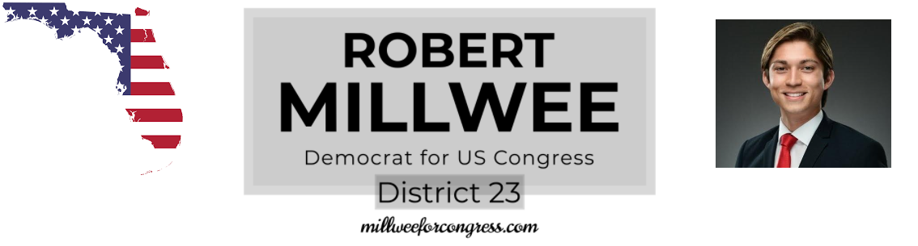
Candidates may collect petitions to have their name placed on a ballot instead of paying high fees. Completing this form does not mean that you endorse the candidate or that you will vote for them. It just makes democracy more accessible for everyone.
Please complete and mail form back to:
1533 Adams St
Hollywood, FL 33020

Political advertisement paid for by Robert Millwee, Democrat, for US Representative FL-23
----------------------------------------------------------------------------------------------------------------------------------------------
